**Assignment 9**

**R-3.11**

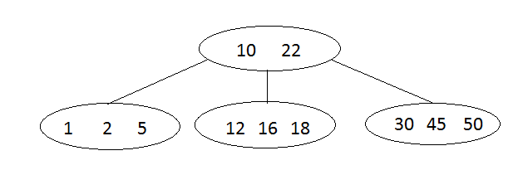

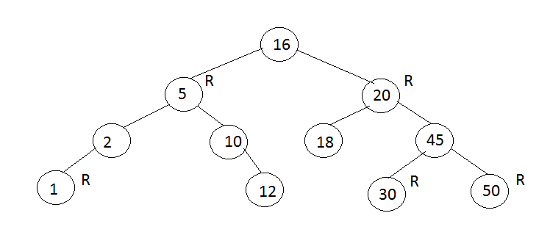

**R-3.14**

1. False, because the root node can’t be red
2. True
3. True, there is only one unique (2,4) associated with a red-black tree
4. False, a single (2,4) tree could have different red-black tree representations

**C-3.10**

**Algorithm** findAllInRange(k1,k2)

S 🡨 new sequence

V 🡨 T.root()

findAllInRange(k1, k2, v, T, S)

return S.elements()

**Algorithm** findAllInRange(k1,k2, v, T, S)

If T.IsExternal(v) then

Return

Else

If key(v) > k1 then

findAllInRange(k1, k2, T.leftChild(v), T, S)

if key(v) ≥ k1 ∧ key(v) ≤ k2 then

S.insertLast(key(v))

If key(v) < k2 then

findAllInRange(k1, k2, T.rightChild(v), T, S)